 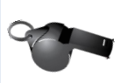  

   

   

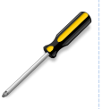  

|  |  |
| --- | --- |
| C:\Users\SCHNEIDER\AppData\Local\Microsoft\Windows\INetCache\Content.MSO\90E64135.tmp [v] | C:\Users\SCHNEIDER\AppData\Local\Microsoft\Windows\INetCache\Content.MSO\90E64135.tmp[f] |